PRITA LEE LESSON SCHOOL
Assignment
Subject. - S.ST Grade -5th
Name. -------------------- Roll no. ------------
Lesson – Movements of Earth

Answer the following questions:-
- What is rotation? How long does the Earth take to rotate on its axis once?
- Explain how days and nights are caused?

Fill in the Blanks:-
- Nicolaus Copernicus said that the Earth revolves around the ___________.
- ____________ is the movement of the earth on its axis.
- To rotate once on its axis the earth takes about ___________.
- The part of the Earth which has __________ is turned away from the sun.
- The Earth has two types of movements __________ and ___________
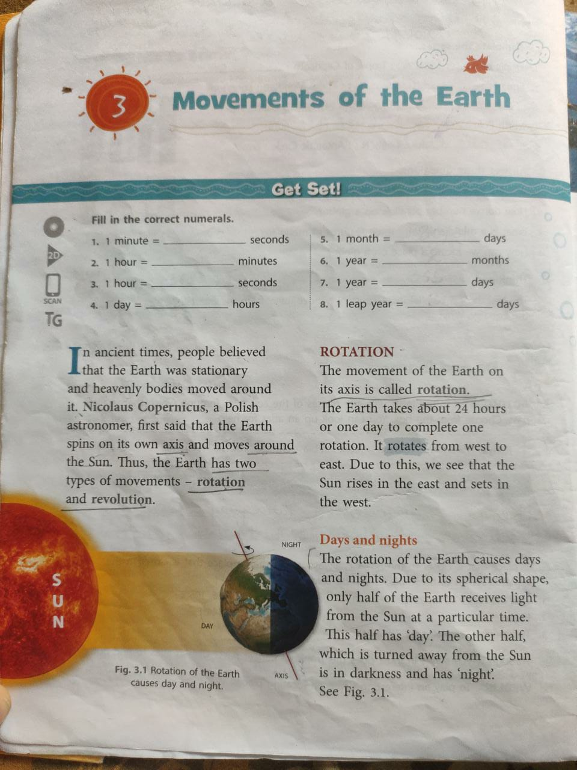
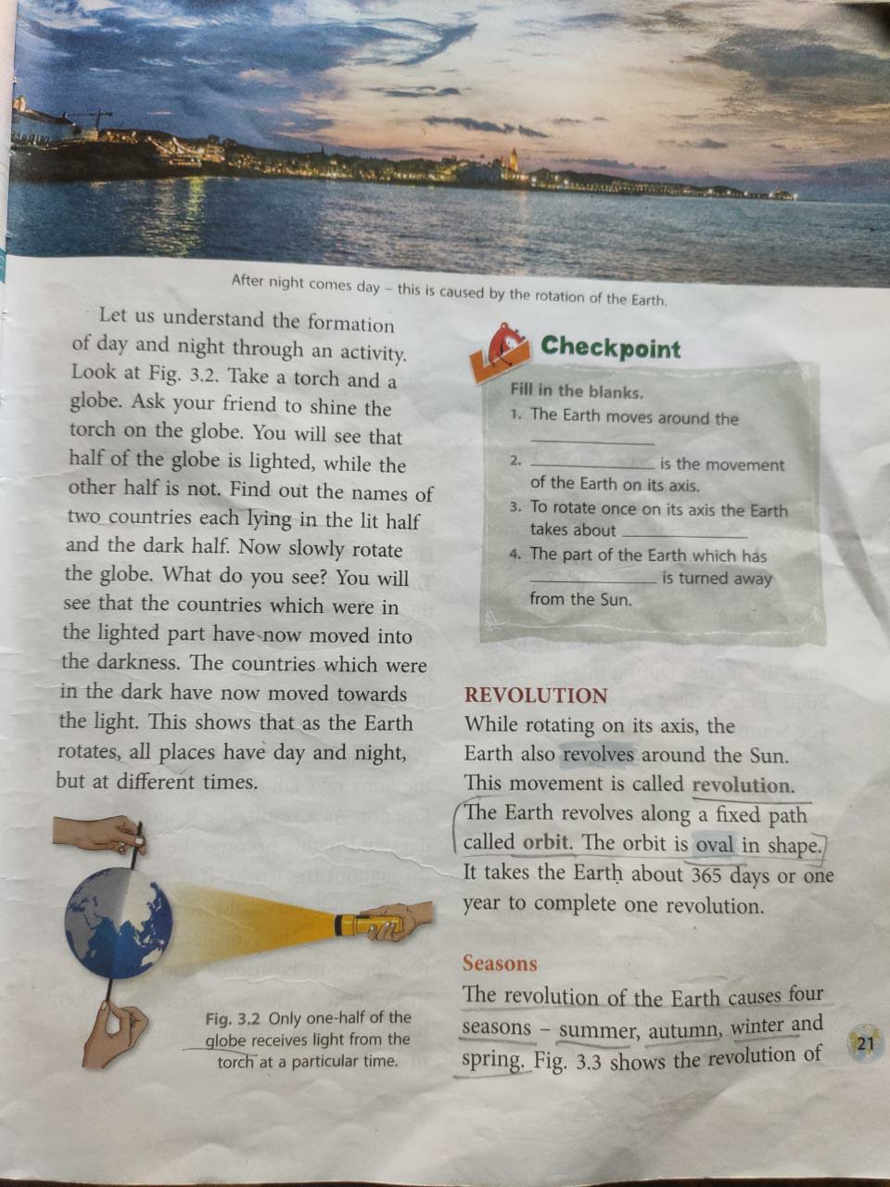
PRITA LEE LESSON SCHOOL
LESSON- PARALLELS AND MERIDIANS
ASSIGNMENT
Name: - -------------------- Roll no -: ----------
Class -: 5th Subject -: S.ST

Answer the following Questions-:
1) Q-: What is a Meridian? Write three features of Meridians?

Answer: - Imaginary Lines running from north to south are called Meridians.
Three features of Meridians: -
- All Meridians are of the same length.
- The maximum distance between any two meridians is at the Equator.
- Meridians cut the parallels are right angles (90°).

2) Q-: How can we locate a place on a Globe?

Answer: - To locate a place, we must know the values of its parallels and its meridians. The point at which the parallel and meridian cross each other is the location of that place.

Fill in the blanks-:
- The Prime Meridian passes through a place called Greenwich.

- To locate a place on a globe we must know its parallel and meridian.

- The network of Parallels and Meridians on the globe is called a Grid.

- Meridians: Longitudes : : Parallels : Latitudes

- Equator : Latitude : : Prime Meridian : Longitude

- 